**Assessing Impact of Digital Lens Usage on Eye Dryness using Schirmer's Effect**

**CAPSTONE PROJECT REPORT**

K .Mysanthosh 21R11A0579

S.Venkatesh 21R11A0550

K.Hemanth Reddy 21R11A0582

P.Saikumar 21R11A0538



Geethanjali College of Engineering and Technology

Cheeryal Village, Keesara Mandal, Hyderabad,Telangana 501301

March 2024

# ABSTRACT

This project aims to investigate the impact of digital screen usage on eye health and associated symptoms among individuals in the digital age. By analyzing various factors such as demographics, usage patterns, environmental influences, symptomatology, and clinical examination results, the study seeks to uncover patterns and correlations that inform strategies for maintaining optimal eye health.

The research will contribute to understanding the prevalence and risk factors of digital eye strain, as well as identifying effective interventions and educational initiatives to mitigate its effects and promote healthy digital device use habits.By studying all these things, we want to find out why some people have eye problems from screens and others don't. Our goal is to figure out ways to keep our eyes healthy even when we use screens a lot. This research will help us understand why eye strain happens and how we can prevent it.

**TABLE OF CONTENTS**

|  |  |  |
| --- | --- | --- |
| **S. No** | **Chapter Name** | **Page No** |
|  | **ABSTRACT** | 2 |
| **1** | **INTRODUCTION** | 4 |
| **2** | **PROBLEM STATEMENT** | 5 |
| **3** | **OBJECTIVES** | 5 |
| **4** | **METHODOLOGY** | 7 |
|  | **4.1 Data Source** | 7 |
|  | **4.2Exploratory Data Analysis** | 9 |
|  | **4.3Slicing and Dicing** | 10 |
|  | **4.4Checking for Data Consistency** | 11 |
|  | **4.5 Data Visualization** | 12 |
| **5.** | **ALGORITHMS** | 17 |
| **6.** | **Results &Analysis** | 20 |
| **7** | **Conclusion** | 23 |
| **8** | **Future scope** | 24 |

**1. INTRODUCTION**

The Schirmer's test is a common diagnostic tool in ophthalmology for assessing tear production, particularly for conditions like dry eye syndrome. During the test, filter paper strips are placed in the lower eyelids of both eyes for 5 minutes after numbing drops are administered. Abnormal results may indicate dry eyes, which can stem from various factors such as aging, inflammation, infections, or autoimmune conditions. Risks associated with the test are minimal, and precautions like avoiding eye rubbing and removing contact lenses are recommended afterward. While the Schirmer's test has been utilized for over a century, newer tests measuring molecules like lactoferrin or tear osmolarity are being developed to enhance accuracy in detecting dry eye conditions.

**Dry eyes may result from:**

* Aging
* Swelling or inflammation of the eyelids (blepharitis)
* Climate changes
* Corneal ulcers and infections
* Eye infections (for example, conjunctivitis)
* Sjögren syndrome
* Vitamin A deficiency
* Risks

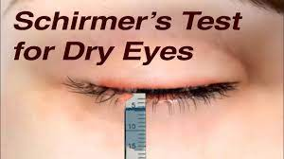 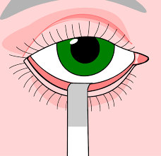

Not detecting Schirmer's eye abnormalities and addressing dry eye syndrome in its early stages can result in worsening symptoms, ocular surface damage, visual impairment, and increased susceptibility to infections and complications. Early diagnosis and appropriate management are essential for preserving ocular health, maintaining visual function, and improving patients' quality of life.

# 2.PROBLEM STATEMENT

Understanding the impact of digital screen usage on eye health and associated symptoms involvesanalyzing various factors like age, duration of screen time, online platforms, nature of activities, screen illumination, years of exposure, daily screen hours, types of devices used, distance from the screen, nighttime usage, blinking frequency, difficulty in focusing, frequency and severity of complaints, observed ocular symptoms, and specific eye examination results.

By examining these variables, we aim to uncover patterns and correlations to develop strategies for maintaining optimal eye health in the digital age

# 3.OBJECTIVES

a. Use Anaconda Python Jupyter for EDA, Data Cleaning & Model building.

b. Identify & Evaluate the best model.

c. Build a web application using Flask API framework.

1. Investigate how prolonged digital screen usage impacts eye health.

2. Identify factors like demographics, usage patterns, and environmental influences contributing to digital eye strain.

3. Uncover patterns and correlations within collected data to understand key factors associated with eye strain.

4. Develop strategies and recommendations for maintaining optimal eye health in the digital age.

5. Contribute to understanding the prevalence and risk factors of digital eye strain.

4.METHODOLOGY

**4.1Data Source**

•The data source is procured from the engineering collage Approaches https://trysakai.longsight.com/portal/site/520b8591-6130-4776-bf04-504e18e885f1/tool/e59fe5bb-2464-4b5c-9679-4d9af5857ede?panel=Main

•The data source comprised of 27 features and 300 observations.

* **Data items for testing is from a below form**





Fig : Survey form related to the given dataset.

* **Brief description of the data source**

|  |  |  |  |  |
| --- | --- | --- | --- | --- |
|  |  |  |  |  |
|  | No. | Data Point | Description |  |
|  | --- | --- | --- |  |
|  | 1 | Age | Age of the individual in years. |  |
|  | 2 | Sex | Gender of the individual (1 for male, 2 for female). |  |
|  | 3 | Wearables | Indicates whether the individual uses wearable devices (1 for No, 2 for Yes). |  |
|  | 4 | Duration | Duration of digital screen usage in hours. |  |
|  | 5 | Online Platforms | Frequency of using online platforms (1 for No, 2 for Yes). |  |
|  | 6 | Nature | Nature of digital screen usage (1 for Continuous, 2 for Interrupted). |  |
|  | 7 | Screen Illumination | Degree of screen illumination (measured in percentage). |  |
|  | 8 | Working Years | Number of years working with digital screens. |  |
|  | 9 | Hours Spent Daily Curricular | Hours spent daily on curricular digital activities. |  |
|  | 10 | Hours Spent Daily Non-Curricular | Hours spent daily on non-curricular digital activities. |  |
|  | 11 | Gadgets Used | Type of gadgets used (1 for mobile, 2 for laptop, 3 for tablet). |  |
|  | 12 | Level of Gadget with Respect to Eyes | Level of gadget with respect to eyes (1 for above eye level, 2 for at eye level). |  |
|  | 13 | Distance Kept Between Eyes and Gadget | Distance kept between eyes and gadget screen (measured in centimeters). |  |
|  | 14 | Avg Nighttime Usage per Day | Average nighttime usage of digital screens per day. |  |
|  | 15 | Blinking During Screen Usage | Indicates if blinking occurs during screen usage (1 for Yes, 2 for No). |  |
|  | 16 | Difficulty in Focusing After Using Screens | Difficulty in focusing after using screens (1 for Yes, 2 for No, 3 for Maybe). |  |
|  | 17 | Frequency of Complaints | Frequency of ocular complaints related to digital eye strain. |  |
|  | 18 | Severity of Complaints | Severity of ocular complaints related to digital eye strain. |  |
|  | 19 | RVIS | Rapid Vision Index Score. |  |
|  | 20 | Ocular Symptoms Observed Lately | Ocular symptoms observed lately (measured in percentage). |  |
|  | 21 | Symptoms Observing at Least Half of the Times | Frequency of observing ocular symptoms at least half of the times (measured in percentage). |  |
|  | 22 | Complaints Frequency | Frequency of ocular complaints. |  |
|  | 23 | Frequency of Dry Eyes | Frequency of experiencing dry eyes. |  |

## 4.2Exploratory Data Analysis

Exploratory Data Analysis (EDA) is an essential step in the machine learning process, where the main goal is to analyze and understand the characteristics of the data before applying any modeling techniques. EDA is the process of summarizing the main characteristics of the data, such as the distribution, the relationship between variables, and identifying any patterns or anomalies that may exist.

EDA is an important step because it allows us to gain a deeper understanding of the data and the underlying relationships between variables, which can help inform decisions about feature engineering, data preprocessing, and model selection. By performing EDA, we can identify any missing or erroneous data, outliers, and inconsistencies in the data, which can be addressed before training any machine

**Information about the Features & their data types**

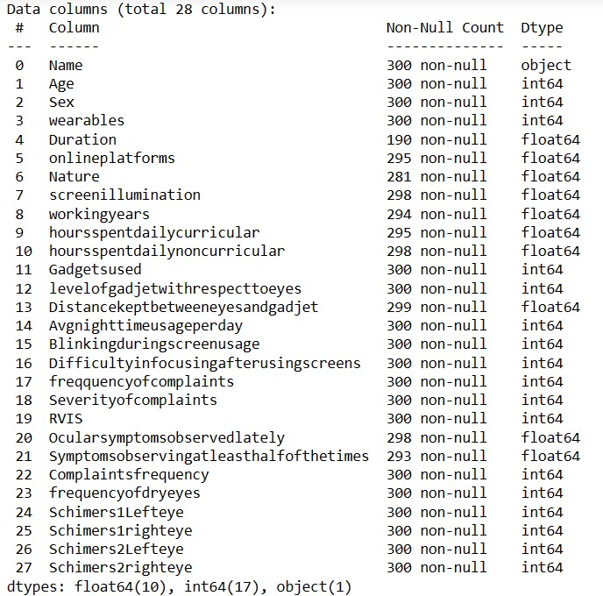

**Observations:**

* Figure 1 provides an overview of the dataset columns, indicating their data types and non-null entry counts. Notably, the 'Name' column is identified as categorical, while other columns initially appear numerical but may also function as categorical due to coded options, as inferred from the survey form.
* Missing values are present in the dataset, necessitating data pre-processing to handle them effectively, either through removal or replacement methods.
* The dataset encompasses multiple target variables such as “Schimers1Lefteye, Schimers1righteye”, and “Schimers2Lefteye”, “Schimers2righteye”. These variables likely correspond to various measurements or aspects associated with eye examinations, indicating the complexity and multidimensionality of the data.

**Revised data frame**

After dropping column ‘Name’, the data frame looks like below.

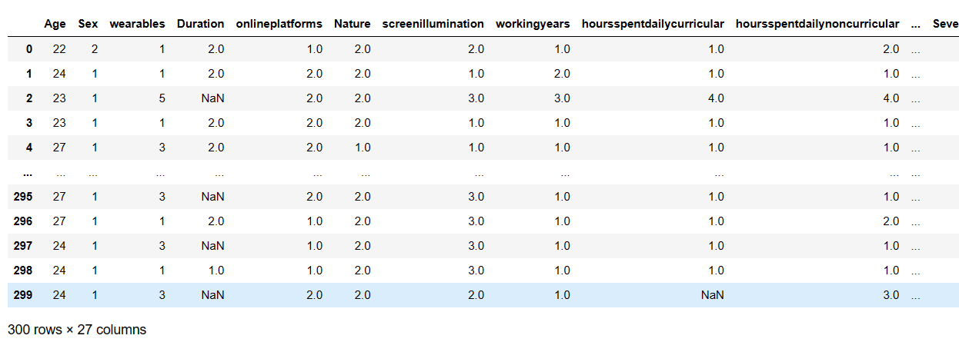

Fig : Revised DataFrame.

**4.3Slicing and Dicing**

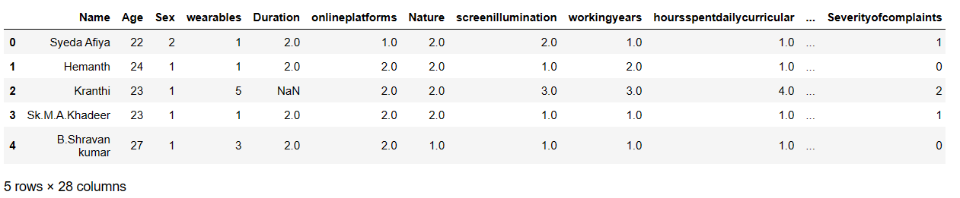

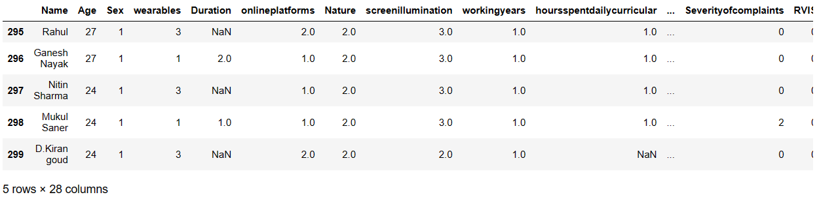

Observation:

The presence of numerous null values in the dataset indicating there are outliers necessitates data cleaning, requiring the replacement of these null values with appropriate statistical measures such as mean, median, or mode.

**4.4Checking for Data Consistency**

* **No duplicates found.**

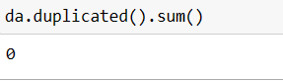

• **Unique Values**

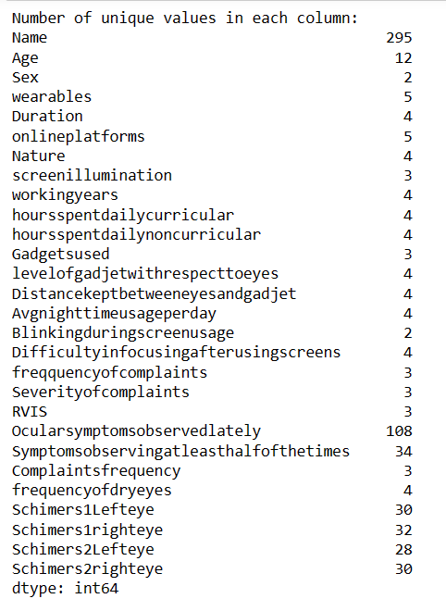

**Data Visualization**

**1.Analysis on wearables**

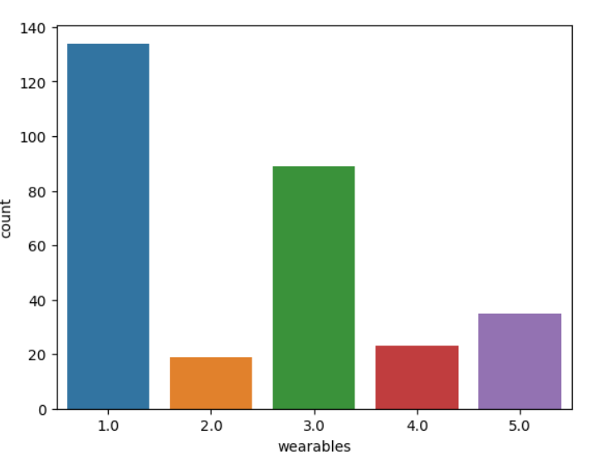

**Observations:**

* **Type 1.0 Wearables(Glasses only)** : This category has the highest count, nearly 140, indicating that it’s the most common type of wearable in the dataset. It suggests that Type 1.0 might be a standard or basic model that is widely used.
* **Type 3.0 (None): With a count close to 80, this type is the second most prevalent in the dataset. This implies that there are close to 80 participants who do not wear any glasses or contacts.**
* **Other Types**: Types 2.0(Contacts only), 4.0(Both,at one or other time), and 5.0(Not applicable) have significantly lower counts, ranging from around 20 to 40. These types might represent more niche or less commonly selected options.
* **Overall Distribution**: The distribution suggests that the dataset is dominated by Type 1.0 wearables, with Type 3.0 next.

**2.ScreenIllumination**

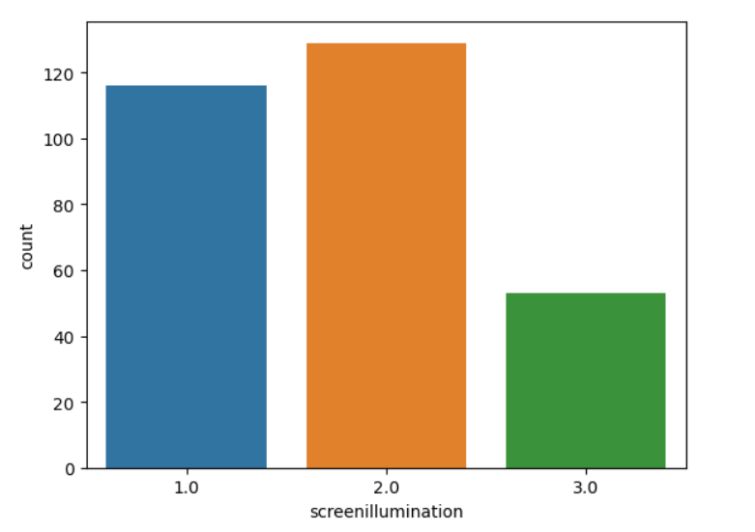

Fig : Graph representing the value count of screenillumination column.

* Screen Illumination 1.0 (Less than 25%): The count for this level is just under 120. This suggests that at this level of screen illumination, the count of the variable is relatively high.
* Screen Illumination 2.0 (25 to 30%): The count exceeds 120 at this level, indicating that this level of screen illumination results in the highest count of the variable among the three levels.
* Screen Illumination 3.0 (greater than 50%): The count is around 40 at this level, which is significantly lower than the other two levels. This implies that this level of screen illumination results in the lowest count of the variable.

**3.Distribution of Age:**

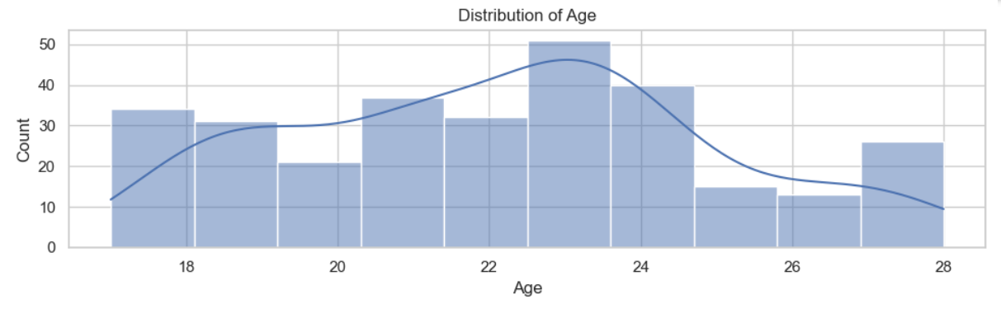

**Observation**:

The histogram reveals that the highest proportion of individuals within the dataset are aged 23, indicating a significant presence of this age group among the population under study.

**4.Distribution of wearables:**

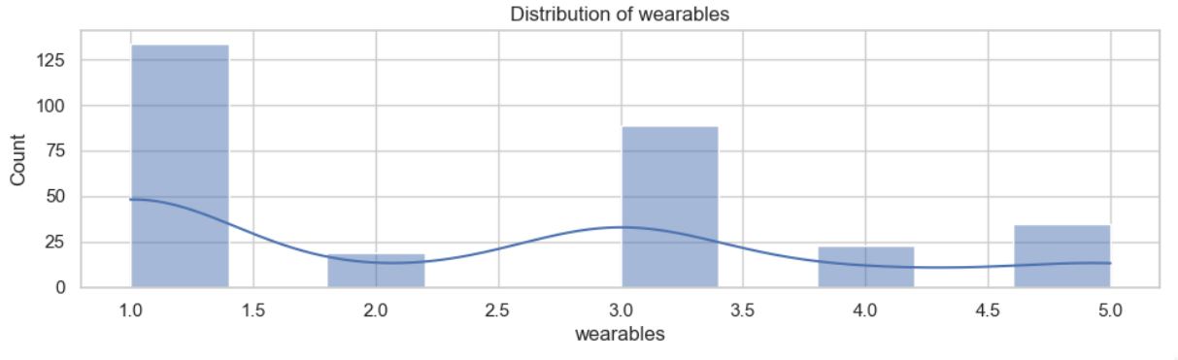

**Observation:**

The histogram highlights a notable prevalence of individuals wearing glasses, with "None" being the next prominent category, indicating those not utilizing any wearables. This suggests that among the various subcategories of wearables, glasses are the most commonly adopted, followed by a sizable portion of individuals opting not to use any wearables at all.

**5.Distribution of Duration:**

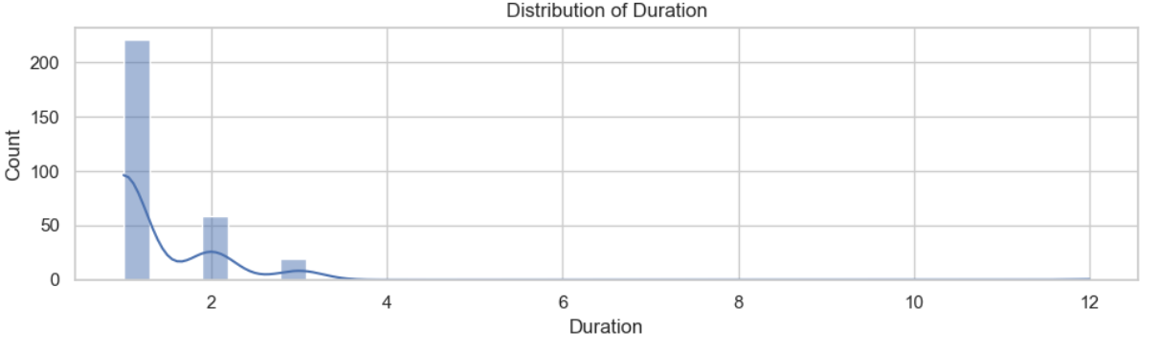

**Observation:**

The histogram illustrates a notable prevalence of individuals using prescription glasses or lenses for less than 5 years, with the 5-10 year duration category being the next most prominent. This suggests that among the duration categories, a significant proportion of individuals have relatively recent usage of prescription glasses or lenses, with a smaller but still notable portion having used them for 5-10 years.

Top of Form

**6.“Schimers1Lefteye”**

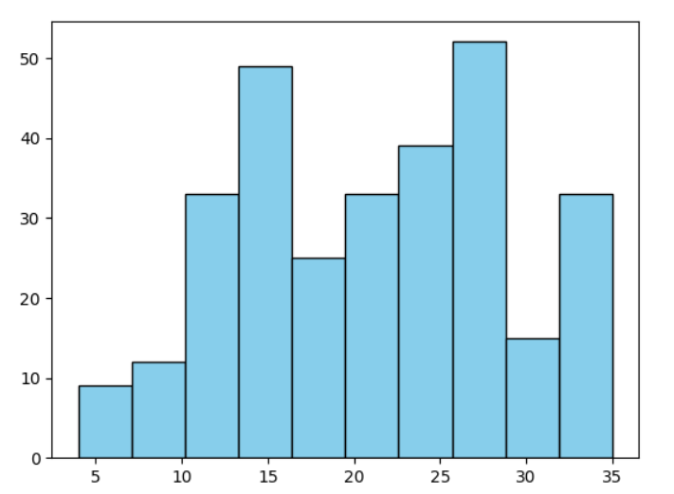

Fig : Histogram showcasing Distribution of values in Schimers1Lefteye.

**Observations:**

* The x-axis represents the values (ranging from 0 to 35).
* Prominent peaks are visible around the values of 15 and 30 on the x-axis.
* Valleys or lower points are noticeable around 10, 20, and 35 on the x-axis.

**7.“Schimers1righteye”**

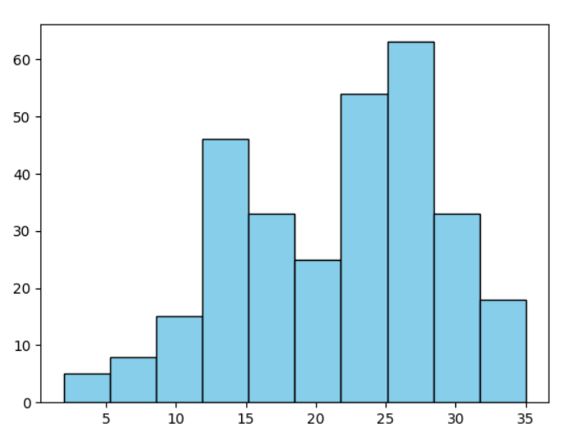

Fig : Histogram showcasing distribution of values in Schimers1righteye.

**Observations:**

* Prominent peaks are visible around the values of 15 and 30 on the x-axis.
* Valleys or lower points are noticeable around 10, 20, and 35 on the x-axis.

**8.“Schimers2Lefteye”**

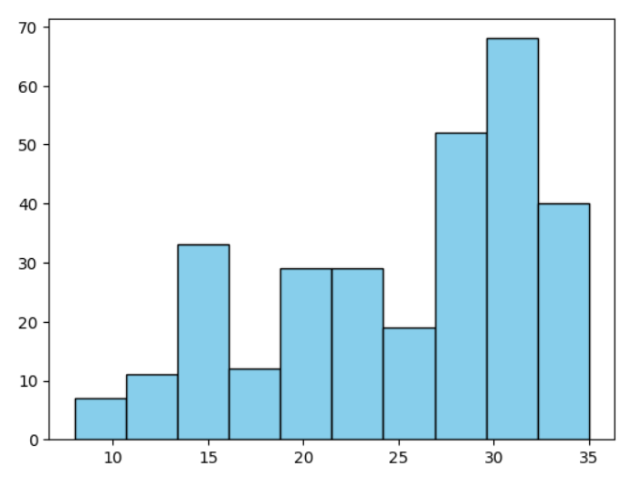

Fig : Histogram showcasing distribution of values in Schimers2Lefteye.

**Observations:**

* The bars initially increase in height, peak around the value of 30, and then decrease.
* The distribution appears **skewed to the right**, as the tail extends further in that direction.

**9.“Schimers2righteye”**

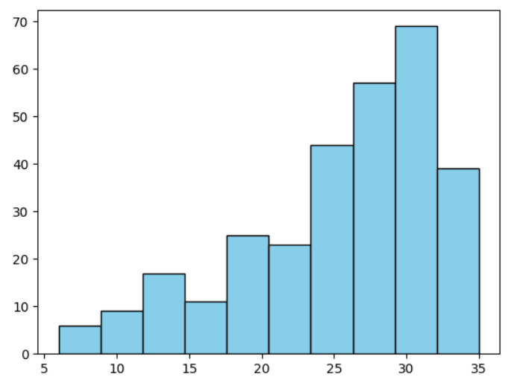

Fig :

**Observations:**

* The bars initially increase in height, peak around the value of 30, and then decrease.
* The distribution appears **skewed to the right**, as the tail extends further in that direction.

**10.Distribution of Gadgetused**

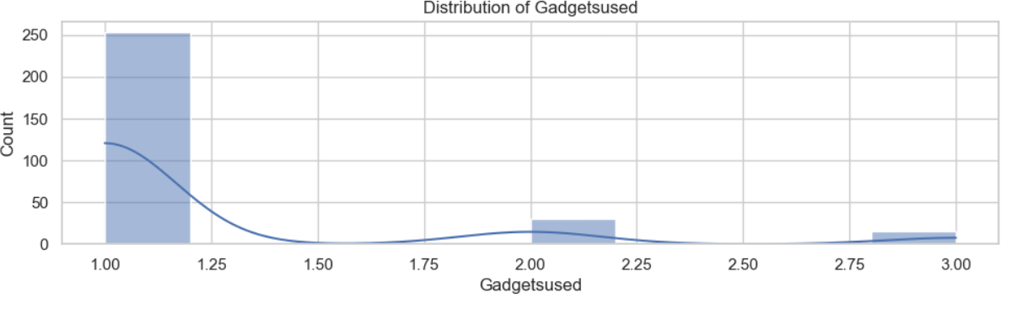

**Observation:**

The histogram plot reveals that the majority of individuals prefer using mobiles over laptops and tablets. This suggests that mobile devices are the preferred choice for most people when it comes to their gadget usage.

**5**. **ALGORITHMS**

**Random Forest Classifier**

**0.9649805447470817**

**Classification Report**

**precision recall f1-score support**

**0 0.96 0.98 0.97 132**

**1 0.98 0.95 0.96 125**

**accuracy 0.96 257**

**macro avg 0.97 0.96 0.96 257**

**weighted avg 0.97 0.96 0.96 257**

**Accuracy: 96.5%**

**Decision Tree Classifier**

**DecisionTreeClassifier**

**DecisionTreeClassifier(max_depth=7, min_samples_split=10, random_state=42)**

**precision recall f1-score support**

**4.0 0.00 0.00 0.00 0**

**6.0 0.00 0.00 0.00 1**

**7.0 0.00 0.00 0.00 1**

**8.0 0.50 0.50 0.50 2**

**10.0 0.00 0.00 0.00 0**

**11.0 0.00 0.00 0.00 4**

**12.0 0.50 0.29 0.36 7**

**13.0 0.00 0.00 0.00 2**

**14.0 0.14 0.20 0.17 5**

**15.0 0.00 0.00 0.00 0**

**16.0 0.00 0.00 0.00 4**

**17.0 0.00 0.00 0.00 0**

**18.0 0.20 0.14 0.17 7**

**20.0 0.00 0.00 0.00 0**

**21.0 0.00 0.00 0.00 0**

**22.0 0.50 0.31 0.38 13**

**23.0 0.00 0.00 0.00 0**

**24.0 0.00 0.00 0.00 1**

**25.0 0.00 0.00 0.00 0 26.0 0.25 0.17 0.20 6**

**27.0 0.00 0.00 0.00 0**

**28.0 0.33 0.08 0.12 13**

**30.0 0.00 0.00 0.00 3**

**...**

**accuracy 0.17 75**

**macro avg 0.11 0.08 0.09 75**

**weighted avg 0.28 0.17 0.21 75**

**Accuracy :17%**

**6.RESULTS & ANALYSIS**

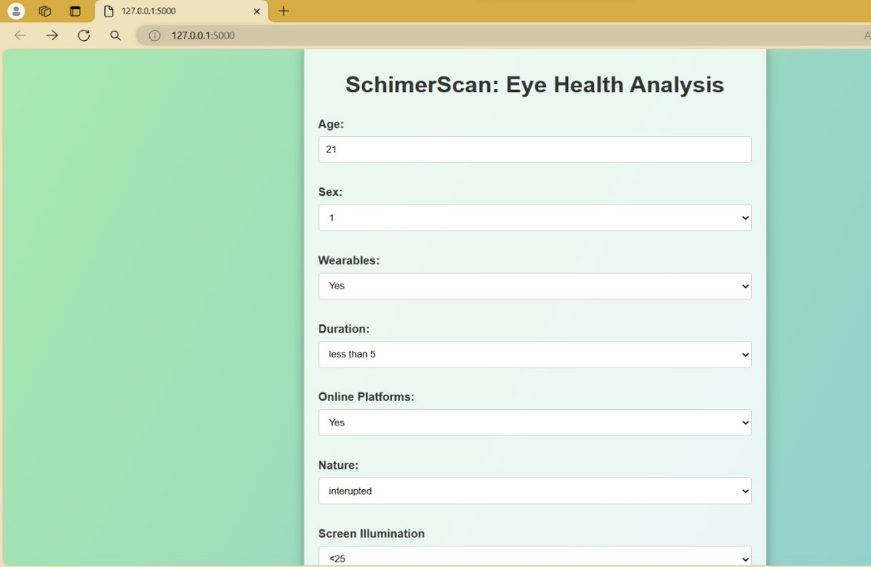

**Fig 1**

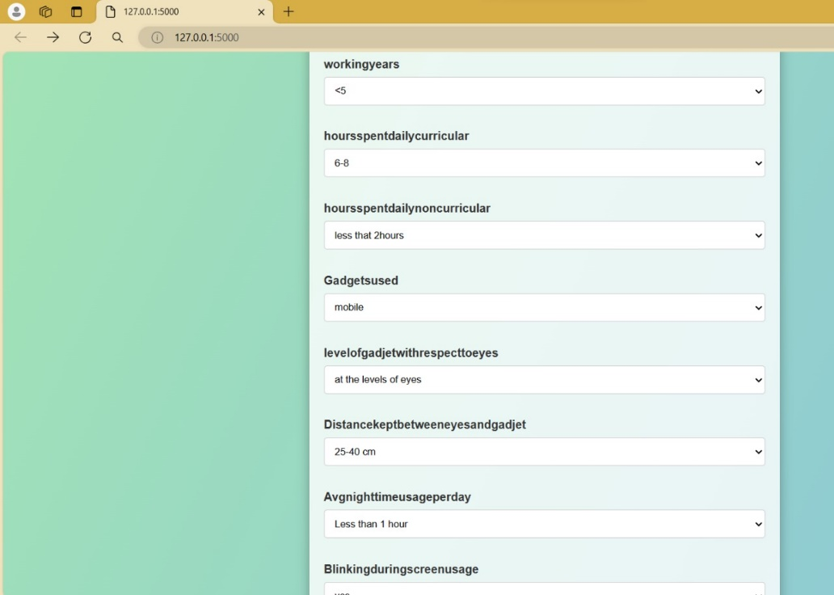

**Fig 2**

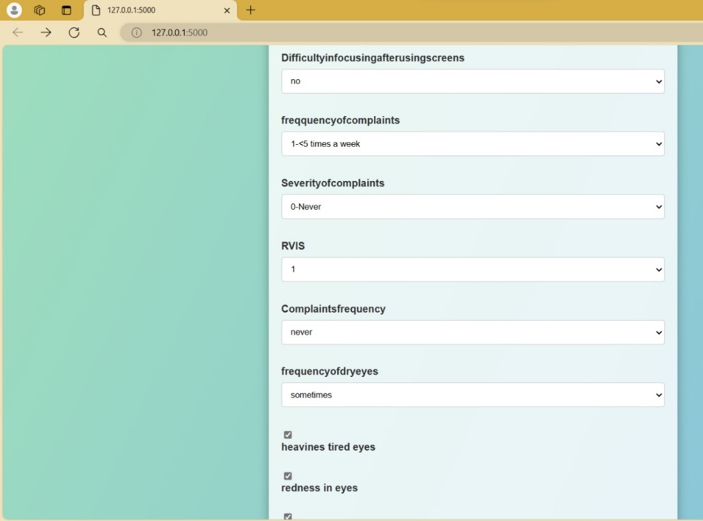

**Fig 3**



**Fig 4**

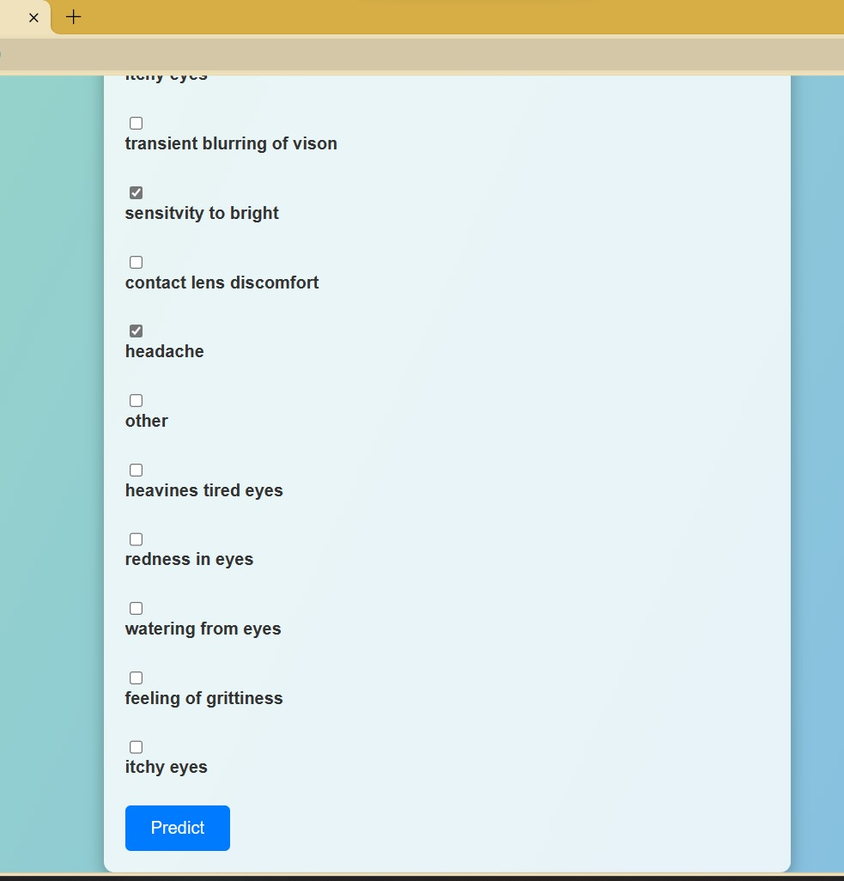

**Fig 5**

**Enter the values for each input tab for getting the predicted values of schrimer test values and select the choice values also**

**Prediction:**

### 

### Final Observations:

* We can clearly see **RANDOM FOREST CLASSIFIER** has outperformed all other models.
* **We can clearly see that the higher test resukts for the schrimer1 right eye and schrimer2right eye compared to lefteye**

# 7.CONCLUSION

This study highlights the impact of digital screen usage on eye health and offers strategies for mitigating digital eye strain. Findings underscore the importance of factors like age and ergonomic practices in alleviating ocular symptoms. Specific interventions, such as ergonomic adjustments, are recommended to promote healthier digital device use habits. This research contributes to advancing knowledge in the field and emphasizes the need for proactive measures to address digital eye strain effectively.

# 8.FUTURE SCOPE

* Longitudinal studies for understanding long-term effects of screen usage on eye health.
* Development of new technologies to mitigate digital eye strain.
* Personalized interventions and educational initiatives to promote healthier habits.
* Collaboration across disciplines for comprehensive approaches.
* Utilization of telemedicine and community engagement for enhanced accessibility to eye care.
* Continued surveillance of trends to adapt interventions  accordingly.